Bioelectrical Impedance Analysis, Pre-Quiz
Name _________________________________

The following questions will survey your current knowledge on the topic of bioelectrical impedance analysis (BIA), which will be covered in this course. Since this quiz is meant to assess the effectiveness of the teaching materials, please answer honestly. If you do not know an answer, feel free to write, “I don’t know.”

1. Consider a series RC circuit carrying AC. What happens to the reactance, impedance, current, and phase angle as the frequency of the AC is increased (assuming the amplitude of the input voltage stays constant)?

confident neutral not confident

I am confident in my answer. 5 4 3 2 1

2. For the circuit described in Question 1, what is the relationship between phase angle, resistance, reactance, and impedance? Draw a graphical representation of these quantities.

confident neutral not confident

I am confident in my answer. 5 4 3 2 1
3. Into what compartments, or components, can the body be divided by the measurement of an AC current across the body? Which components are analogous to resistance? Which are analogous to capacitance?

confident neutral not confident

I am confident in my answer. 5 4 3 2 1

4. When taking a BIA measurement of the body, what does the BIA device actually measure? How is this translated into fat free mass (FFM)?

confident neutral not confident

I am confident in my answer. 5 4 3 2 1

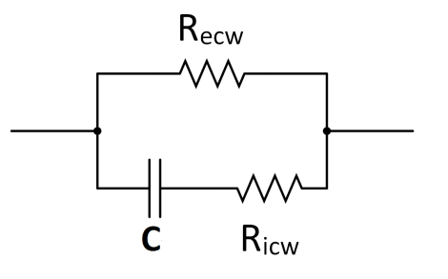
5. Consider the circuit shown to the right. How do you expect the impedance and phase angle to change for this circuit as frequency increases? How is this similar to or different from the bioelectrical properties of the body?

confident neutral not confident

I am confident in my answer. 5 4 3 2 1

Bioelectrical Impedance Analysis, Post-Quiz

Name _________________________________

The following questions will survey your current knowledge on the topic of bioelectrical impedance analysis (BIA), which will be covered in this course. Since this quiz is meant to assess the effectiveness of the teaching materials, please answer honestly. If you do not know an answer, feel free to write, “I don’t know.”

1. Consider a series RC circuit carrying AC. What happens to the reactance, impedance, current, and phase angle as the frequency of the AC is increased (assuming the amplitude of the input voltage stays constant)?

confident neutral not confident

I am confident in my answer. 5 4 3 2 1

2. For the circuit described in Question 1, what is the relationship between phase angle, resistance, reactance, and impedance? Draw a graphical representation of these quantities.

confident neutral not confident

I am confident in my answer. 5 4 3 2 1
3. Into what compartments, or components, can the body be divided by the measurement of an AC current across the body? Which components are analogous to resistance? Which are analogous to capacitance?

confident neutral not confident

I am confident in my answer. 5 4 3 2 1

4. When taking a BIA measurement of the body, what does the BIA device actually measure? How is this translated into fat free mass (FFM)?

confident neutral not confident

I am confident in my answer. 5 4 3 2 1

5. Consider the circuit shown to the right. How do you expect the impedance and phase angle to change for this circuit as frequency increases? How is this similar to or different from the bioelectrical properties of the body?

confident neutral not confident

I am confident in my answer. 5 4 3 2 1

