**Computed Tomography**

**Objectives**

* Describe the basics of how computed tomography makes an image through back projection.
* Demonstrate a practical application of SOH CAH TOA and the line equation *y=mx+b*.
* Understand terms important to CT such as image artifacts and windowing
* Find the location and diameters of objects inside an opaque mystery box

**Equipment**

* Photogate, rotary motion sensor and LabPro
* Rod and bolt to attach the photogate to the rotary sensor
* Rotating platform and base with angular scale
* Angular indicator
* Rotary sensor stand
* Congo Blue #181 light filter enclosure

**Part One: Pre-lab Discussion**

*X-rays*

X-rays are high energy electromagnetic radiation with wavelengths smaller than those in the visible spectrum (0.01-10nm and 400-800nm respectively). As X‑rays pass through a person some of the X-rays will be absorbed, meaning fewer X-rays leave the body than entered it. This is called attenuation and is larger (fewer exiting X-rays) for denser material. Bone, for example, attenuates X-rays more than muscle since bone is denser.

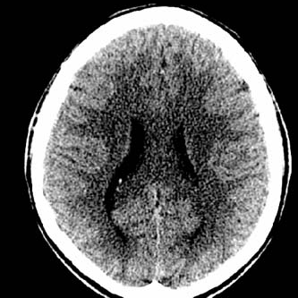

**Fig. 1.1. Cranial CT scan. The white region is the skull and the darker regions are soft tissue. Source: *Computed Tomography: From Photon Statistics to Modern Cone-Beam CT***

Images produced with X-rays are like shadows, showing where the X‑ray radiation passed through the body and where it was absorbed. Dark regions on an X-ray image correspond to tissue with smaller attenuation coefficients and lighter regions with denser tissue like bone (see Fig. 1.1).

The main drawback to X-ray imaging is that intense or prolonged exposure leads to serious health problems such as cancer and radiation burns. High energy X-rays can change the molecular structure of tissue, sometimes causing a person’s DNA to mutate faster than normal. Because of this drawback, the goal of all forms of X-ray imaging is to acquire the best possible image while submitting the patient to the lowest possible dose of radiation.

*Computed Tomography*

One of the limitations of planar images like chest X-rays are that they are a two dimensional representation of a three dimensional object. This limits the amount of information that can be discerned. For example, an X-ray of a box, in which a cone and sphere are placed, may look something like Fig. 1.2(a). From this we may be able to say what kind of objects they are but not their relative locations. For example, is the sphere in front of the cone or is the cone in front of the sphere? But if we rotate the X-ray 90o relative to the box we may get an image like Fig. 1.2(b). This is the basic idea behind computed tomography where multiple X-rays scans from different angles are put together to form an image. Of course this also means that the radiation dose for a CT scan is larger than for a regular single X-ray scan.

(b)

(a)

**Fig. 1.2 . Projections of a sphere and a cone. (a) A single image imparts a limited amount of information. (b) Another image taken from a different angle can reveal additional information.**

*Back Projection*

Back projection is one of the most common methods for reconstructing an image. The images in Fig. 1.2 are called projections. In a CT scanner, an X-ray source rotates around an object producing area projection data at each angle. That data is spread back onto an image of the area, which is divided into pixels. Pixels are the individual units of the reconstruction. Each pixel has a certain value attached to it which corresponds to the attenuation at that point (Fig. 1.3). When put together, all the pixels reveal an image. As more and more X-ray scans are taken and data is back projected, an image of the area starts to emerge. It is important to note that because projection data are collected from multiple angles, CT imaging results in a higher dose of radiation than planar imaging. Today patients receiving a CT scan are exposed to the equivalent of 30 to 442 chest x-rays per scan.

The near IR-light used in a photogate has a larger wavelength (880nm) and therefore lower energy than X-rays. Infrared light is quickly attenuated by water inside the human body and is not suitable for medical imaging of deep tissue. However, it is able to pass through material with low attenuation coefficients like the Congo blue light filter used in this experiment. The projection data recorded by the photogate will be a digital signal of 0 (unblocked) and 1(blocked), rather than the continuous signal of an X-ray based CT scanner.

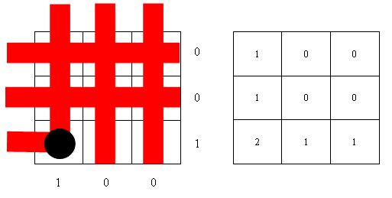

Photogate scans



Back Projection

**Fig. 1.3. Projection data is smeared back onto a reconstruction of the scanned area. Pixels of higher values correspond to the position of the object. The projection data are the 0s and 1s to the right and bottom of the first grid and represent the unblocked and blocked states of the photogate respectively.**

*Geometry*

Once the Photogate is blocked and we have projection data to work with, the computer spreads that data back onto the reconstruction graph. To do this we need to mathematically describe each scan. This requires us to find an equation for the imaginary line from the light source of the photogate to the detector, relative to the scanned area. The only data we have as inputs are (see Fig. 1.4):

(1) Focus-Center-Distance (FCD) - the distance between the rotational axis and the origin

(2) $θ$- the angle between the rotational axis and the negative x-axis

(3) $ϕ$- the angle between the FCD and the scanning line

We can use geometry and trigonometry to find the equation of the scanning line. All we need are some trig identities (SOH CAH TOA) and the formula for a line (*y=mx+b*). There are multiple formulas we use to describe specific scanner geometries. Which formula we choose for the scanning line changes depending on the values of $θ$, $ϕ$,and the FCD. Each possibility is programmed into the computed tomography program, which selects the appropriate formula based on the inputs.

Rotational Axis

Focus-Center-Distance (FCD)



y

x



**Fig. 1.4 . Geometry of the CT scanner, the Scanning line represents the line connecting the light source and detector of the photogate**

IR Source

IR Detector

**Part Two: Computed Tomography Scan**

In this activity you are given a mystery box, in which 1 to 3 cylinders were placed by the instructor before class. This enclosure should be sealed so that the locations of the cylinders are unknown. You will use a photogate, rotary motion sensor and a LabVIEW program to make an image of the contents of the enclosure. Using that image, you will determine the position and dimensions of the cylinders inside.

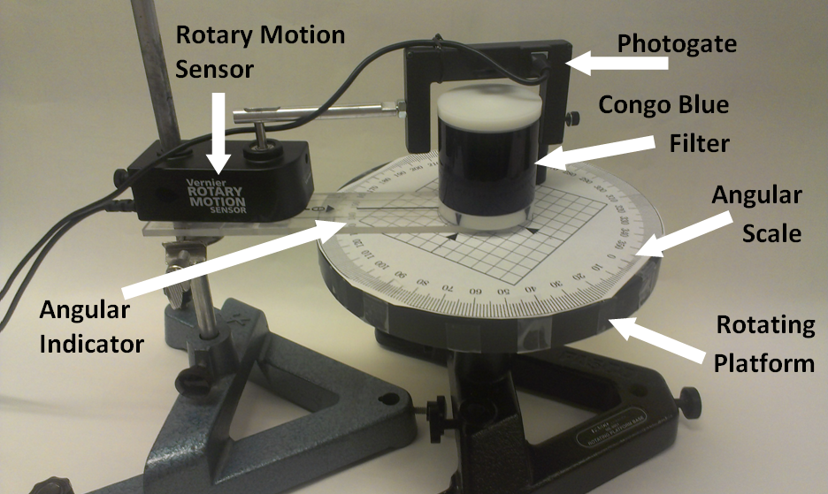

**Fig. 2.1. Computed Tomography Apparatus**

**LabPro/Computer Setup**

1. Make sure the LabPro is connected to a USB port
2. Plug the photogate into the Dig/Sonic1 jack and the rotary motion sensor into the Dig/Sonic 2jack*.*

**Apparatus Calibration**

Open the program Computed Tomography and click on Manual Scanner. Follow the on-screen instructions.

**Data Collection**

*Using a Cylinder at the Origin*

1. Place a cylinder at the origin of the grid on the rotating platform and click BEGIN SCAN. Slowly move the photogate over the cylinder and observe how the back projected data is displayed in the reconstructed image. Note that if the photogate is moved too quickly, the Scan Speed indicator will flash red.

* **Q1: Which scan speed do you think will result in a higher quality image: fast or slow? Why?**
* **Q2: Could slower scan times be dangerous in medical CT? Why?**

*Using the Mystery Box*

1. Place the enclosure on the grid and align them by matching the marks on the side of the enclosure to the arrows printed on the grid.
2. Click BEGIN SCAN and slowly move the photogate over the enclosure.
3. Once the photogate has made a complete pass, click Forward, rotate the platform to the angle on the θ Control and scan the enclosure again. Repeat until you have completely rotated the platform and θ = 355o.

* **Q3: The CT program records data for θ = 0o, 10o, 20o…170o then shifts to θ = 175o, 185o, 195o…355o. Why do you think the angles are shifted? How would the data for θ = 0o and θ = 180o compare?**
* **Q4: An image artifact is a false representation of the actual scanned area. Does your final image show any artifacts? What caused the artifacts?**

1. Adjust the Window slider to highlight important data and obscure any artifacts.

* **Q5: Describe why the image is changing.**
* **Q6: Describe how changing the Window improved the image.**

1. Right click on the cursor toolbar and click on Create Cursor>Free. Using the cursor(s) determine the position and diameter of each object.

To display a cursor, right click on the cursor area below the graph and go to Create Cursor>Free. Click and drag the intersection of the two lines of the cursor to the center of the object. The corresponding grid markers on the left and bottom of the scan area indicate the location.

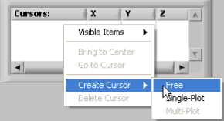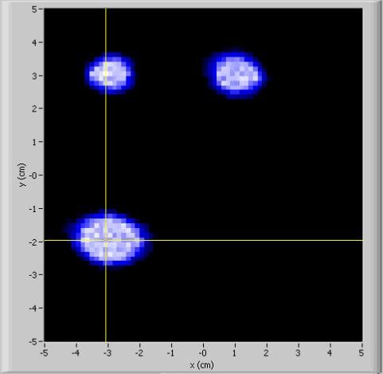

* **Q7: Do the objects in your scan look circular? If not, what could be done to improve your image?**

1. Save an image of your reconstruction by either right clicking the intensity graph and selecting Copy Data or by pressing Print Screen on your keyboard (Mac users: ⌘ + Shift + 3) then pasting the image in another program like Word or Paint. And then print the image. *Make sure to include this in your lab notebook.*

* **Q8: Do the contents of the mystery box correspond to your scan? Find the percent difference between your observations and the actual diameters of the cylinders (0.5 cm) using the formula below.**

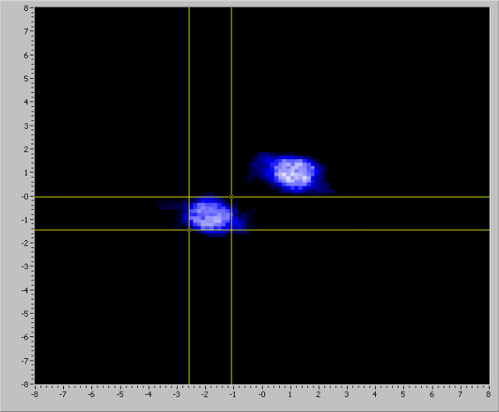 

*This is an example of the calculation of the scanned objects given in the materials list.*

*For this object, the cursors indicate a horizontal diameter of 1.6 cm and a vertical diameter of 1.4 cm.*

*The average is 1.5 cm. This average is used as the acquired value.*

*The object was measured to be 1.3 cm, therefore the calculation for percent difference is:*



* **Q9: How would you obtain a 3-D image of the object?**
* **Q10: Summarize how your image was obtained. How is this experiment different from a real CT scan?**