Lab Exercise: RLC CIRCUITS AND THE ELECTROCARDIOGRAM

## OBJECTIVES

* Explain how resistors, capacitors and inductors behave in an AC circuit.
* Explain how an electrocardiogram (EKG) works
* Explain what a voltage divider is and how it works
* Explain how the EKG sensor filters out unwanted noise

# PART ONE: RESISTORS, CAPACITORS AND INDUCTORS IN AC CIRCUITS

## EQUIPMENT

|  |  |
| --- | --- |
| * Function Generator * 800-loop coil + iron core * 10  Resistor, 100 F or 330 F Capacitor | * Wires * Current and Voltage Probes |

Electronic filters are essential in devices that require analyzing particular frequencies of electronic signals such as in the electrocardiogram. You will investigate a *low-pass filter*, a *high-pass filter*, and a *band-pass filter*. A low-pass filter allows low frequency signals through while attenuating (decreasing amplitude) current or voltage signals of higher frequencies. Similarly a high-pass filter allows high frequency signals through and attenuates current or voltage signals of low-frequency. A band-pass filter attenuates all frequencies except for a narrow band. After understanding these filters, you will learn how they can be used practically by exploring the limits of an electrocardiogram, a device created to measure electrical signals from the heart. To comprehend how filters work we need to better understand alternating current, to which you were introduced in the previous lab.

In this part of the experiment you will examine the filtering of alternating current in a circuit with a resistor, capacitor, and inductor at different frequencies.

# PREPARATION

In the previous lab you investigated an AC circuit containing a resistor, a capacitor, or an inductor. You learned that in an AC circuit the resistance *R* must be replaced by impedance *Z* :

  (1)

where *V* and *I* are either the root mean squares or the peak values of the oscillating voltage and current.

The impedance for a circuit with resistors, capacitors and inductors is given by:

(2)



 

2

2

*C*

*L*

*X*

*X*

*R*

*Z*

−





where *X*B*L*B and *X*B*C*B vary with the frequency *f*, according to:

  (3)

*L* is the self-inductance and *C* the capacitance.

When *XL* and *XC* are equal to each other, the impedance *Z* is at a minimum and **electrical** **resonance** occurs. Note that when *Z* is at a minimum, **current is at a maximum**. The **resonant frequency** of a circuit is calculated by setting *XL* and *XC* equal to each other to obtain

 (4)

## Figure 1. Resistor, Capacitor and Inductor in an AC circuit.

 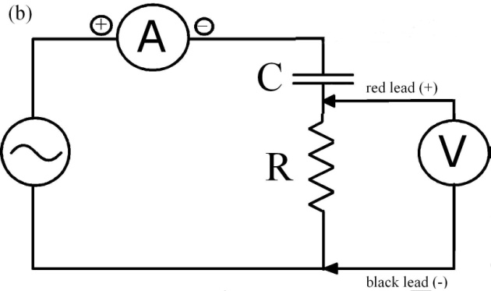

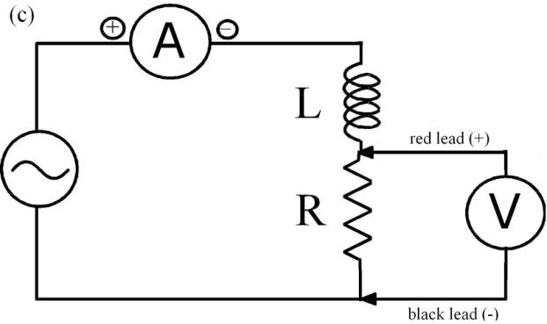 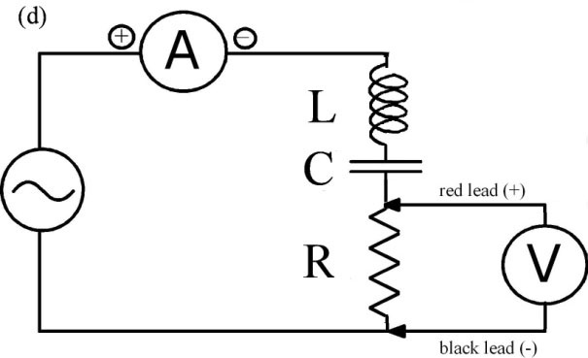

* **Q1: Consider the diagram in Figure 1a and recall how the amplitude of voltage changed with frequency for this circuit from your previous lab work. Is this circuit a low-pass, high-pass, or band-pass filter?**
* **Q2: Consider the diagram in Figure 1b and recall how the amplitude of voltage changed with frequency for this circuit from your previous lab work. Is this circuit a low-pass, high-pass, or band-pass filter?**
* **Q3: Consider the diagram in Figure 1c and recall how the amplitude of voltage changed with frequency for this circuit from your previous lab work. Is this circuit a low-pass, high-pass, or band-pass filter?**

PROCEDURE

* + - 1. If using the dual-channel amplifier, connect the voltage probe into Probe 1 and the current probe into Probe 2. Connect channel 1 and channel 2 of the LabPro to the dual-channel amplifier. Otherwise, connect the voltage probe into channel 1 of the LabPro jack and the current probe into channel 2. In LoggerPro go to File and then Open. Open the PSU folder and then double-click on the RLC Circuit file. You should now see a current vs. time and a voltage vs. time graph.
      2. Zero both probes.

1. Connect the circuit shown in Figure 1d with the AC function generator, a 10 resistor, the 800-loop coil with the iron core, a capacitor, and a voltage and current probe. Note that the positive lead from the function generator should be plugged into Lo Ω and the negative lead should be plugged into GND. The positive ends of both the voltage probe and the current probe should be closest to the Lo Ω side of the circuit.
2. Turn the function generator on and adjust the frequency to 60Hz by rotating the “adjust” button. Set the waveform to the sine wave setting. Push collect. Adjust the Amplitude knob on the function generator until the voltage peaks at +/- 2 V.
3. After adjusting the voltage, vary the frequency from 1 Hz to 150 Hz.

* **Q4: How does the amplitude of the voltage change with frequency for this circuit? Use Eq.** **(1), Eq. (2) and Eq. (3) to explain your observation. Have you created a low-pass, high-pass, or a band-pass filter?**
* **Q5: What is the resonant frequency of the circuit?**

1. To observe the phase change across the whole circuit, move the voltage probe so that it measures across all three circuit components. Adjust the Amplitude so that the voltage and current peaks are visible on the graph. Vary the frequency from 1 Hz to 150 Hz.

* **Q6: What do you notice about the phase difference between current and voltage at resonance?**
* **Q7: Using the resonant frequency you found in question 5 and the capacitance of the circuit, what is the inductance of the coil?**

Close down Logger Pro when finished.

**PART TWO: THE EKG**

**EQUIPMENT**

|  |  |
| --- | --- |
| * EKG sensor * EKG electrodes * circuit board * Venier LabPro interface | *  and k resistors * Vernier LabQuest * 3.5mm mini stereo plug and wire with 20k resistors  * Standard voltage probe |

An electrocardiogram sensor, also referred to as an EKG or ECG, is designed to obtain a graphical interpretation of the electric activity of the heart and is used in the investigation of heart disease. This lab introduces the EKG as a medical device that works as a voltage probe and band pass filter.

**The Heart**

To understand what an EKG is measuring, a dipole and depolarization must be introduced.

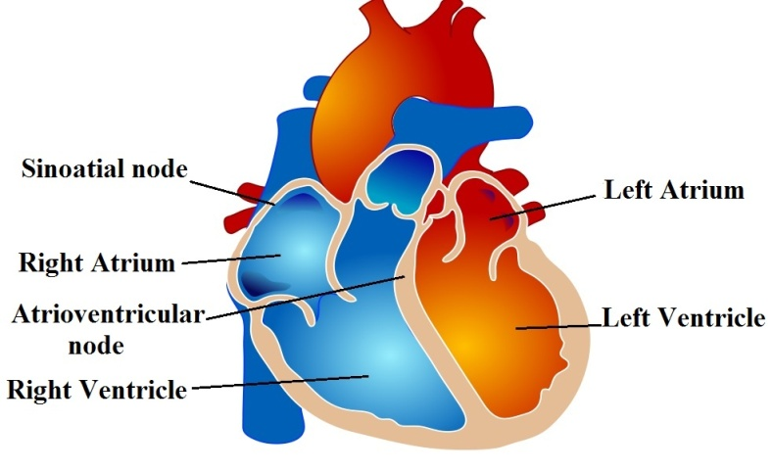

**Figure 1- The anatomy of the heart**

If we think of the activity of the heart in the light of electrostatics, the heart can be viewed with a slightly positive pole and a slightly negative pole, or **dipole**. A dipole can be considered as a separation between positive and negative charges. **Depolarization**, or a change in the charge of the nerve cells, sweeps across both atria and down though the ventricles during the contraction. This changes the magnitude and direction of the heart’s dipole as the contraction occurs. An EKG is designed to measure this changing dipole.

Shown in Fig. 2 is a graph of a typical waveform measured by an EKG representing the changing dipole of the heart through a single cycle of the heart beat. This type of graph is referred to as a tracing. There are common repeating features of the EKG tracing, in particular the P wave is caused by the spreading impulse from the SA nodes, the QRS complex is from the depolarization of the ventricles, and the repolaraztion of the ventricles causes the T wave. A trained medical practitioner can analyze the tracings from an EKG and diagnose many possible ailments of the heart based on irregular rhythms or features.

**Figure 2 - Typical P-QRS-T wave structure of a single heart beat.**

**The EKG**

Two of the three inputs of a three-lead EKG are there to act as voltage measuring points. If the voltage potential (indicating the direction of the heart’s dipole) is greater at the “positive” red lead than it is at the “negative” green lead, the EKG tracing will show a positive measurement. Likewise, when the potential is greater at the green lead the tracing will show a negative potential. The third input, placed far from the heart and the other two leads, is there to remove noise signals that are common to all three inputs and therefore not an electrical signal from the heart. A common source of noise in the hospital environment is electrical signals from other medical equipment and the third lead is used to remove much of that noise.

Seen in Fig. 3 is the flow chart of the EKG functions. First the EKG sensor amplifies the small input signal from the heart and any other electrical sources that are present; we will refer to these other sources as noise as they do not carry any information we are interested in. The EKG filters out the noise by filtering out frequencies of the input signal that do not carry any meaningful information about the heart’s activity. There are two stages to this filtering, a **high-pass filter** removes frequencies that are too **low**, including constant voltage offsets, and a **low-pass filter** removes frequencies that are too **high**. We will explore in the lab the desired range of frequencies.

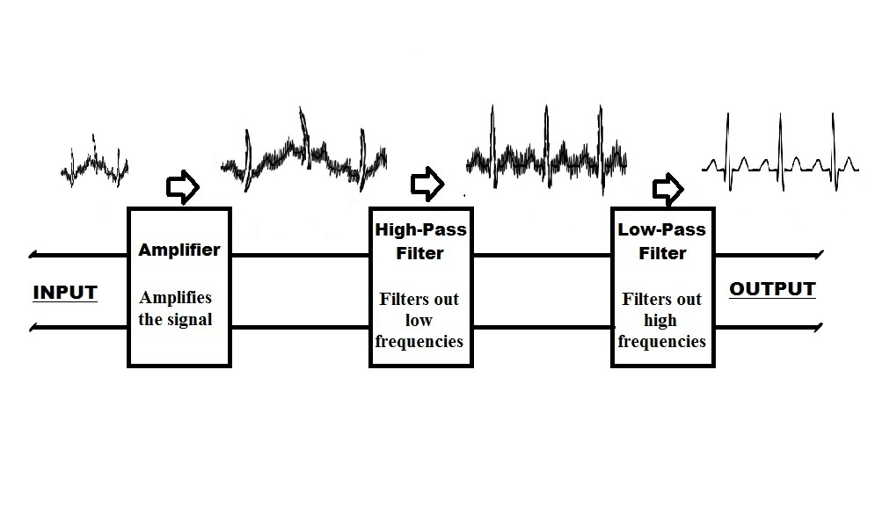

**Figure 3 - Block diagram of EKG functions**

This type of graphical recordings is not limited to only the heart muscle; it can also be used to show the electrical activity within other muscles. Similar to changing electrical fields in the heart, the contraction or relaxation of skeletal muscles involves ions flowing across the cell membranes and thus causing a net change in the electric field. This change can be measured using the voltage probe that would, in this case, be called an electromyogram or EMG.

Before we dissect how the EKG works, let’s first become acquainted with the EKG as a medical device. In this section we will attach the EKG leads to one of the lab partners and monitoring the electrical activity of the heart while resting and while exercising. In addition, we will find the heart rate using the tracings obtained from the EKG. This section will give us a general idea of how to interpret the EKG tracing and help us understand what changes occur in an EKG tracing under different conditions.

**PROCEDURE**

**Setup**

* Plug in the EKG sensor to “Channel 1” of the Venier LabPro. Open LoggerPro.( LoggerPro should open to a potential vs. time graph)
* Attach the three electrodes to you or your lab partner as indicated in Fig. 4 after rubbing your arm at the lead contact points with a mild abrasive such as a napkin or paper towel to remove any dead skin or oil that may compromise the adhesion of the leads. Be careful to place the red lead on the left arm and the green lead on the right arm.

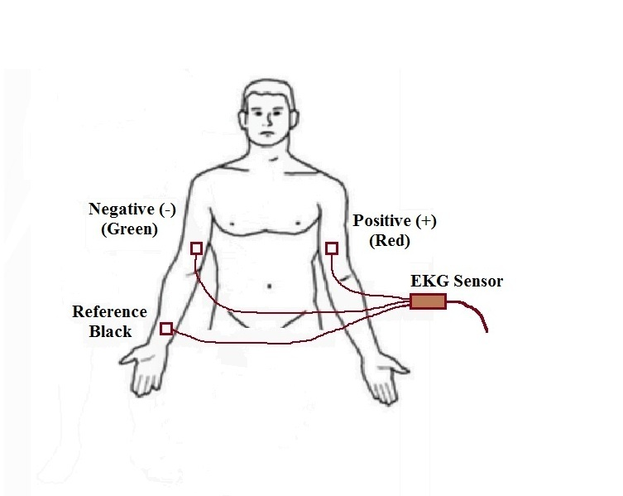

**Figure 4- EKG lead placement**

*Experiment 1- Analyzing a standard EKG reading*

* Under the *Experiment* tab in LoggerPro select *Data Collection*. Set the length of the experiment to 5 seconds and press *Done*. Push *Collect.* It is important that you do not move your arm during the time of recording.
* Once you have identified the first peak of the QRS wave in the graphed tracing, count how many peaks, *N*, appear in the graph. Also record the time, *t*, it took from the first peak to the last in seconds below.

N ______

t (s): ______

* Find the frequency of your heart beat using equation (1).

$f=\frac{N-1}{t}$ (6)

* Calculate the heart rate using equation (2).

$Heart Rate= \frac{N-1}{t}*\frac{60 s}{1 min}$ (7)

**Q8: Based on your measured heartbeat, at what range of frequencies should the EKG be sensitive? What do you think should be the maximum and minimum of that range and why?**

**Q9: Consider that the direction of the heart’s electric dipole changes during the heartbeat cycle. When a max amplitude appears on the tracing, what does this mean about the direction of the heart’s dipole in relation to the direction of the leads?**

*Experiment 2- Changing the EKG pattern through physical exertion*

* Run in place for one minute, sit back down and then collect for another 5 sec.

**Q10: Do you notice any difference? What has changed?**

**Q11: Why do you think the components of the wave are the same?**

**PART THREE: THE EKG AS A VOLTAGE PROBE AND AMPLIFIER**

In this section we will explore the use of the EKG as a simple voltage probe and in particular explore the main operation of the EKG as a voltage amplifier. We will compare the EKG probe to a standard voltage probe and show how the EKG is designed to maximize readings from the heart.

**PROCEDURE**

*Experiment 3- Voltage differences using a voltage divider*

In order to take advantage of the EKG’s ability to measure small voltage differences, it is necessary to decrease the voltage output of the function-generator using a voltage divider. A voltage divider can be as simple as two resistors in series. The voltage divider, shown in Fig. 6, acts by decreasing the voltage over either resistor as compared to the input voltage from the generator, *Vin*. It can be shown using Ohm’s law, (*V= IR*), and Kirchhoff’s Loop Rule (the sum of all voltage drops over a loop must equal the sum of all voltage gains), that *Vout*, the measured voltage across *R1*, will be given by equation (3):

$V_{out}=\frac{R_{1}}{R_{1}+R_{2}}V_{in}$ (8)

* Set up the voltage divider as indicated by the circuit diagram in Fig. 5. For the resistors, use R1 = 100 Ω and R2 = 220 kΩ.

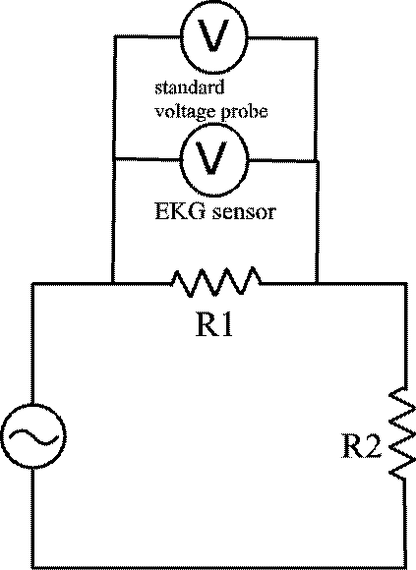

**Figure 5- Measuring voltage across a resistor using a voltage divider**

* Place either the left or right audio out wire from the LabQuest on one end of the circuit. Place the green and black leads from the EKG on one side of R1 and the red lead on the opposite side. Place two leads from the standard voltage probe on opposite sides of R1 as well.
* Press *Collect*. While collecting adjust the amplitude/voltage of the signal coming from the LabQuest function generator so that it varies from about 0 to 3 mV as measured by the EKG. Also, while collecting, *autoscale* the standard voltage probe graph.

**Q 12: For which graph do you see more noise?**

**PART FOUR: NOISE REDUCTION IN THE EKG - FILTERING**

In this section we will explore another primary function of the EKG, eliminating extraneous noise. The EKG eliminates unwanted signals in order for the physician to get a clear signal of the heart’s operation. You will use a Vernier LabQuest for this portion of the lab. The LabQuest is capable of producing AC signals, a repeating alternating change in electric potential that also corresponds with a change in direction of current. **Note that whereas in Part I of this lab the LC circuit functioned as a current-filtering circuit, the frequency-dependent filtering of the EKG device is seen in its voltage reading.** Electronic filtering, therefore, can take different forms depending on the purpose for which it is needed.

**PROCEDURE**

*Experiment 4- Introducing and filtering a high frequency noise source*

This experiment is designed to show how the EKG sensor can work as a low-pass filter thereby filtering out high frequency noise. You will be introducing two different frequencies into a circuit, one that is within the range of frequencies that the EKG sensor lets through, which we will refer to as the signal, and the other that is above the frequency that the EKG sensor lets through, which we will refer to as the noise.

* Using the LabQuest and the supplied 3.5 mm stereo plug with resistors, wire a connection from the left and right stereo outputs to the same point on a breadboard. The LabQuest audio channels will act as two signal sources, one the “Simulated Heart Signal” (SHS) and one as a “noise” source. Set up the same circuit as used in the last experiment as shown in Fig. 7, with the LabQuest audio outputs in place of the function generators, making sure to wire the ground wire from the audio cable to R2. The EKG and voltage probe leads should be connected across the 100 Ω resistor (R1 = 100 Ω and R2 = 220 k Ω).

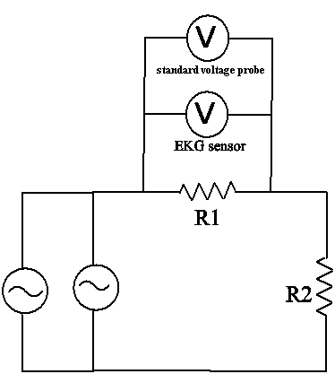

**Figure 6- Circuit diagram using the LabQuest as two function generators, one to act as a 1 Hz "signal" and one to output the "noise".**

* Using the LoggerPro Audio Function Generator interface, set both the both waveforms to output sine wave patterns at amplitudes of 100%. Set the frequency of the left waveform (acting as the SHS) to 1 Hz and right waveform (acting as the noise) to 300 Hz.
* Press *Collect* on the LoggerPro interface and adjust the noise source from 300 Hz down to 50 Hz.

**Q13: What were the observed results? For what frequency (approximately) does the EKG begin to filter out the noise and show a clean signal? You may want to try the experiment multiple times to narrow down the frequency.**

**Q14: Is this low-pass or high-pass filtering? For which circuit component from part 1 did you see this type of filtering?**

The short term magnitude variations of the wave are due to the limited data collection timing of the equipment and will alter with the frequency. In fact, this sampling issue is one of the reasons filtering is needed in EKG design. We have used 250 samples/sec to sample at as that seems to be about the maximum samples a second that we can observe in real time with our equipment. It would be ideal to actually record many times more samples a second than the frequencies we are actually observing. The magnitude variations we observe at around half the sampling frequency (125 Hz in our case) and at various frequencies above this are due to an issue called “aliasing” where we are not sampling often enough and therefore different frequencies will actually appear in the sampled data as copies or aliases of each other. We observe this near 125 Hz where we see a very low frequency change in the amplitude of the signal. If these higher frequencies were not filtered out, the artifacts of this sampling issue could appear as low frequency signals from the heart. A full discussion of this issue goes beyond the scope of this lab, but, again, are a primary reason filtering is needed in EKGs.

*Experiment 5- Introducing and filtering a low frequency noise source*

This experiment is designed to show how the EKG sensor can work as a high-pass filter thereby filtering out low frequency noise and bias offsets.

* Connect the standard voltage probe across the 220 kΩ resistor. With the EKG leads again connected across the 100 Ω resistor and the LabQuest leads connected across both resistors, set the SHS to output 1.0 Hz as the signal. Adjust the amplitude so that the standard voltage probe measures a variation of about -2 to 2 volts. Set the noise source to output a DC signal by changing the frequency to 0 and the amplitude to about 25%.
* Press *Collect* in LoggerPro and increase the amplitude on the noise source to increase the DC signal.

**Q15: What were the observed results for both probes? Does the EKG reading depend on how rapidly you increased the amplitude? You may need to run this experiment multiple times to be sure of your observations.**

**Q16: Is this low-pass or high-pass filtering? For which circuit component from part 1 did you see this type of filtering?**

*Experiment 6- Varying frequency to determine band-pass limits of the EKG*

* Set up the circuit in figure 6, but with the voltage probe across the 220 kΩ resistor. Set the frequency and amplitude of the noise source to 0.With the frequency of the SHS set to 1 Hz, set the amplitude so that the signal varies by about 1.5mV as measured by the EKG.
* In LoggerPro press *Collect,* and over the collection period of 15 sec, gradually turn the frequency up from 1 Hz to 20 Hz going slowly at the beginning. Note how the amplitude as measured by the EKG varies with frequency.
* Now set the SHS frequency and amplitude to 0. Start the frequency of the SHS at 20 Hz. Click on *collect* in LoggerPro and gradually turn the frequency up to 100 Hz over the 15 sec of collection time.

**Q17: How did the amplitude as measured by the EKG vary with frequency over the range from 0.1 Hz up to 100 Hz? What approximate range of frequencies was measured to have the greatest amplitude as measured by the EKG? You may need to take another measurement or two to narrow your range.**

**Q18: Why is it beneficial for the EKG to have the greatest measurements over the range you measured?**

**Q19: Is this low-pass filtering, high-pass filtering, or band-pass filtering? Did you observe similar behavior in any of the circuits from part 1, and if so, which one?**

***PLEASE CLEAN UP YOUR AREA AND STRAIGHTEN YOUR CHAIRS, SO THE STATION IS READY FOR THE NEXT STUDENTS TO USE IT*.**

**Lab Exercise:** LRC AND AC, FILTERS, AND THE ELECTROCARDIOGRAM

**Notes for the Instructor:**

To use the audio function generator on the LabQuest using LoggerPro we bought stereo audio cables with a 3.5mm plug to bare wire (<http://www.amazon.com/3-5mm-Stereo-Right-Angle-Plug/dp/B004GIKSN6>) and soldered resistors with high resistance (we used 4.7kΩ), to each of the left and right audio out channels. The high resistance should help in limiting the effect of each channel on the other when combining the output from both channels.

It is useful to give the students an overview of the LoggerPro output and circuit board before attempting to complete this lab. The features of the LoggerPro output worth noting are how to adjust the frequency and the amplitude. Also, while this lab does not use any waveform other than a sinusoidal waveform it may be useful to indicate to the students that it is possible to generate other types of wave forms. While the circuit board is not required, it does make it useful to clip multiple voltage probes onto the same resistors. The students should be made aware of which points on the circuit board are connected together (same voltage) and a general overview of how to place a circuit across two points in the board.

In experiments 5, 6, and especially 4, the students will see aliasing effects due to under sampling. We are limited to about 250 samples/sec to observe the data collection in real-time and due to limitations of the EKG sensor. However, it would be ideal to sample at many times the highest frequency we are measuring. It should be made clear to the students that this is a byproduct of the equipment we are using, is one of the factors that need to be considered in EKG design, but is not the primary effect that we intend to observe in those sections.