Lab Exercise: Magnetic Resonant Imaging

Objectives
After completing this lab, students should be able to:
- Describe the magnetic fields produced by moving charges
- Explain the importance of hydrogen in MRI
- Describe the Larmour frequency
- Describe how an image is formed using MRI

Introduction
Magnetic resonance imaging (MRI) has become an essential diagnostic tool worldwide due to its ability to non-invasively depict and distinguish soft tissues within the body. At the most basic level, it utilizes an induced magnetic field and a pulsed radio frequency wave to create detailed images of a patient. Several key discoveries paved the way for its creation including the theories of electromagnetism, nuclear physics, and quantum mechanics, which led to the discovery of characteristic particle spin.
Over the course of the 19th century Michael Faraday, James Clerk Maxwell, and others laid the foundational theories of electromagnetism. There was found to be an inherent duality in nature between magnetic and electric energy fields, which could be manipulated and quantified in concert with one another.

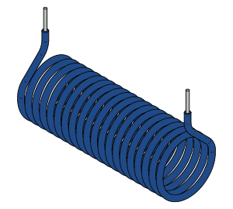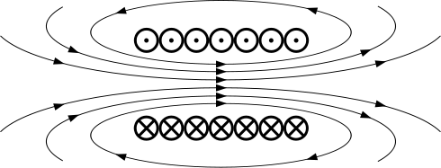

Figure 1. A solenoid and a cross-section of a solenoid. A current through the magnetic field produces a magnetic field, represented by the arrows.

An MRI device contains a solenoid that carries high currents to generate a magnetic field of a few Tesla. Figure 1 shows a cross-section of solenoid. Crosses represent a current into the paper and dots represent a current out of the paper. From the right hand rule you can find the direction of the resulting magnetic field depicted in the figure.

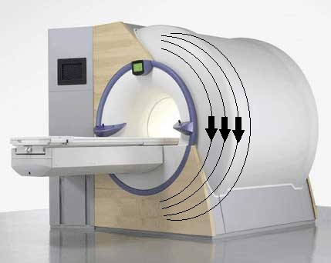

- Q1: On the image of the scanner, use the right hand rule and draw the direction of the induced magnetic field. The arrows denote the direction of current through the solenoid.
The discovery of nuclear spin states has had a great impact on how we understand the quantum nature of particles. Imaging technologies such as nuclear magnetic resonance (NMR) spectroscopy and MRI are the result of our growing knowledge in this field. It has been shown that a nucleus will occupy either one of two orientations. This intrinsic physical property is what is manipulated by an MRI machine.
The human body is composed primarily of hydrogen atoms (63%) and most of our tissues contain roughly 75% water. MRI machines that are currently used for clinical diagnostic purposes make use of this fact through what is known as the chemical shift. The chemical shift is defined as the difference in resonant frequency between isolated hydrogen and its value when bound to a specific site within a molecule. Different tissues will contain diverse chemical compositions/environments, and therefore different chemical shifts, allowing for discernable contrast between them.
Both protons and neutrons have a magnetic moment. Unless the nucleus contains an even number of protons and an even number of neutrons, the atomic nucleus has a net magnetic moment. A nucleus must have a net magnetization for it to be discernable using magnetic resonance spectroscopy.

- Q2: From the list below circle possible candidates for magnetic resonance spectroscopy (you may need to look at a periodic table, unless specified otherwise choose the most abundant isotope for each element ):

Carbon¹³ Helium Carbon¹² Calcium

Oxygen Hydrogen Phosphorous Sulfur
An MRI scanner is comprised of several components including a very large solenoid, which creates the magnetic field (B-field) within the central canal where the patient lays. That magnetic field aligns the nuclei in the patient’s body parallel to its B-field.

A radio pulse excites the nuclei of the body tissues to transiently flip spin states. As the nuclei flip and realign, they produce detectable amounts of photons. These gradient coils can either be built into the large head unit or customized for individual body parts. During the imaging, the current from these coils are turned on and off in intervals and are used to precisely shape the image that is collected. It is the forces generated on these gradient coils by the main static magnetic field that generates the loud “knocking” noises that are associated with the scan. The video link below provides a good demonstration of the overall components of a scanner and the general process that takes place when using one.
http://www.analogic.com/collateral/documents/english-us/mr-qt.html

PART ONE: Calculating the Larmor Frequency and using a MRI computer simulation

- Open the MRI java simulation (http://phet.colorado.edu/en/simulation/mri) and click on the simplified MRI tab.

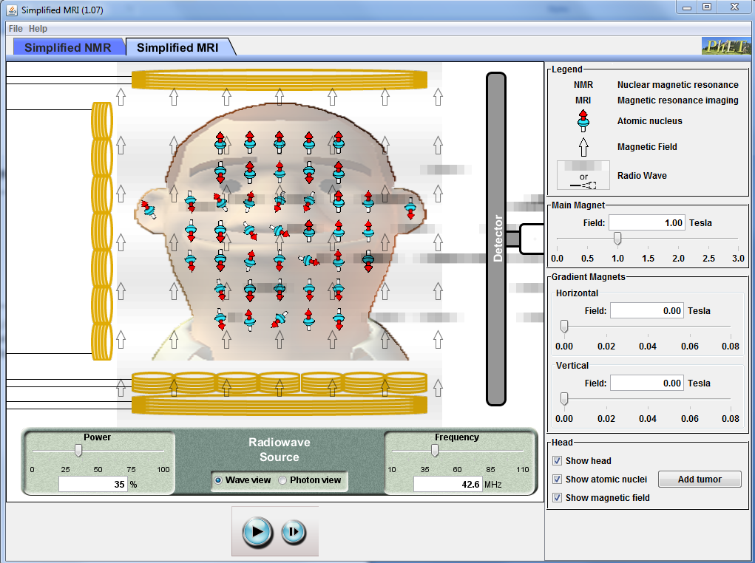
Try both wave and photon view and choose the one you prefer

Make sure that the Head, atomic nuclei and the magnetic field boxes are selected.
Begin with the main magnetic field at 1.00 Tesla and turn the power up to 100 %

- Now adjust the frequency bar to different levels and describe what you notice. Find the frequencies that stimulate the nuclei. Are there a wide range of frequencies that promote a resultant photon? What happens as you decrease the power?
The value that you just recorded for your resonance frequency is known as the Larmor frequency. This is the frequency at which the hydrogen atoms will flip between spin states and emit resultant photons. In order to calculate the Larmor frequency we must first find the difference in energy states for the hydrogen nucleus.
- Q3: Calculate the ΔE value for hydrogen at 1 Tesla.

- Q4: Using the equations from the front page, create a single equation that relates the energy difference and the associated frequency.

- Q5: Calculate the theoretical Larmor frequency for a magnetic field of 1 T. How close was your value to the predicted value above from the applet?

- Calculate the Larmor frequency for B = 2 T. Check your answers using the java program. This time, set the power to 100% and change your frequency to the result you calculated and drag your magnetic field accordingly until you reach the max output. Were the values close?

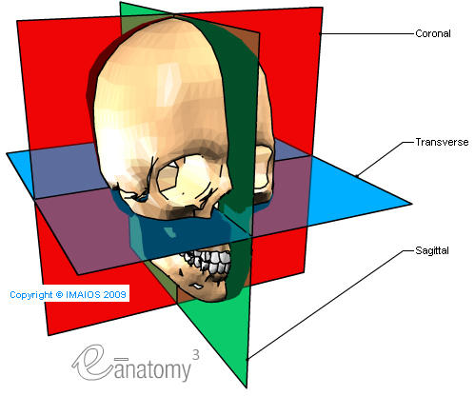
PART TWO: Dealing in Single Planes
As with several other diagnostic imaging devices, most of MRI images are taken in a single plane. In fact, CT scans require hundreds of individual slices to comprise their three-dimensional images. As a result, it is important for physicians to become comfortable dealing with viewing images from different orientations throughout the body.

- Q6: On the MRI images below, give the name of the specific plane that each image was taken from and suggest which region of the body is shown.

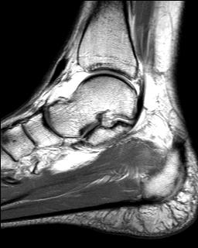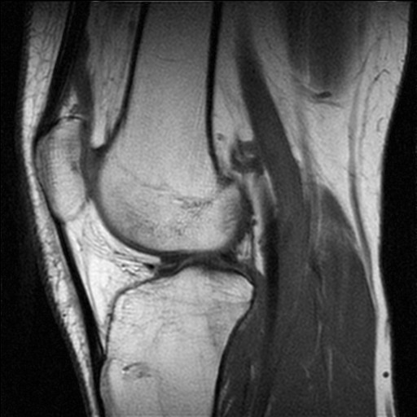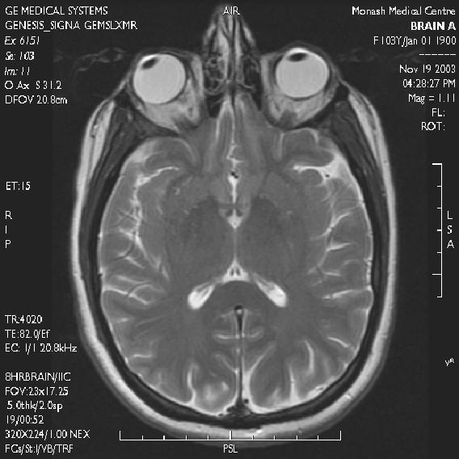
(A) (B) (C)
Image | A | B | C
Plane
Body Region

In order to generate a slice, the MRI needs to excite hydrogen nuclei in one plane. This is done by adding a gradient magnetic field.
- Adjust the slider of the vertical field first to 0.04 T and then to 0.08 T. What do you observe?
- Press Add tumor and try to selectively target the hydrogen nuclei at the location of the tumor. You can achieve this by changing the frequency of the radio wave or by changing the strength of the main magnetic field. Note: In an actual MRI neither is done and the gradient magnetic field is changed.

- Q7: Explain why changing the strength of the gradient field allows the selective stimulation of the hydrogen nuclei in one slice.

