Radiography Experiment
Purpose
This simple radiography experiment uses an apparatus that mimics a planar x-ray imager. By analyzing how the apparatus works, a general understanding of how radiography works is gained. First, different attenuation coefficients are observed for different materials. Then, two planar images of unknown objects will be observed and recorded to determine the objects’ shape and orientation. From this simple exercise, the basic methods of radiography as well as some fundamentals of electromagnetism should be understood.
Materials/Equipment
- Apparatus
  - LED array
  - Four 9V batteries
  - Phosphor screen
  - Base for all components
- Different Materials Sheet
- Removable Congo blue filter box
- Objects to be determined
- Black box to cover apparatus for viewing in a well lit room
- Cell phone with digital camera
Theory and Calculations
In the 19th century, James Clerk Maxwell postulated that electromagnetic radiation was of wavelike form. In the 20th century, Albert Einstein claimed that electromagnetic radiation was a particle, called a photon. The energy of a photon is $E=hf$, where h is Planck’s constant, and f is the frequency of the radiation. Wave-particle duality is now accepted and describes that electromagnetic radiation travels like a wave and interacts like a particle.
Since the accidental discovery of x-rays by Wilhelm Röntgen in 1895, many applications have been found for the radiation. An x-ray, or x-radiation, is simply electromagnetic radiation similar to visible light. X-rays, however, differ from visible light in their frequency and wavelength. The wavelength of electromagnetic radiation is inversely proportional to the frequency f, and the frequency is directly proportional to the energy: $λ∝\frac{1}{f}$ and $f∝E$.
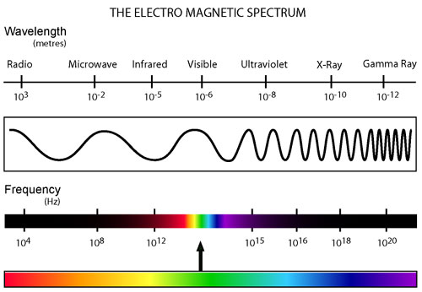
Figure 1 – Electromagnetic spectrum. Notice x-rays have a short wavelength, which means a high energy¹.
Notice in the electromagnetic spectrum of Fig. 1 that x-rays have a much shorter wavelength than the visible light portion. The wavelength of x-radiation ranges from 0.01 nm to 10 nm while visible light ranges from 390 nm to 700 nm. The near infrared radiation emitted by the LEDs used in this lab have a wavelength of 940 nm. A shorter wavelength corresponds to a higher energy, which is why x-rays can damage DNA and are considered carcinogenic. On the flip side X-ray radiation can penetrate deep into human tissue and can be used as a diagnostic tool or to destroy cancerous tumors.
- What is the relation of wavelength to frequency for electromagnetic radiation? Think about speed: $Speed=\frac{Distance}{Time}$. What would the speed be in the case of electromagnetic radiation? Use the wavelength as a distance and frequency as inverse time.

- Write down the equation for the energy of a photon in terms of frequency and again in terms of the wavelength.

- A long wavelength corresponds to a _____energy.

- A high frequency correspond s to a ____ energy.

- Calculate the frequency range (in Hz) and energy range (in eV) for x-rays, visible light, and the near infrared radiation of the LED (c = 3.0 x 10⁸ m/s and h = 4.1 x 10⁻¹⁵ eV∙s).

X-rays used for diagnostic means are commonly produced in the following manner. An x-ray tube within the machine contains an electron gun, where electrons are emitted from a heated filament. By applying oscillating potentials to the electrons, a linear particle accelerator is used to accelerate the electrons to high speeds to achieve a large kinetic energy. The electrons are then fired at a heavy metal such as tungsten. Upon colliding in the metal, the particle suddenly decelerates and x-rays are emitted, a process called brehmsstrahlung or braking radiation. With enough energy, the emitted electron can also knock an electron at a low level within the metal out of its shell. When a higher level electron drops to fill it, an x-ray photon is emitted. These are called characteristic x-rays as they are specific to the energy level of the metal target.
Like visible light, x-rays can be scattered or absorbed by different materials depending on the attenuation, density, and thickness of the material. Attenuation is the loss of intensity of light through a material. If a material has a high attenuation, the intensity of the radiation decreases upon passing through the material due to absorption and scattering. The x-ray attenuation coefficient for soft tissue, bone, and lead are shown for varying photon energies in Fig. 2. In hospitals, lead is used to screen the radiation so it cannot harm areas that are not targeted by the x-rays. X-rays used for imaging purposes pass through tissue and muscle without a large loss in intensity, but are absorbed and scattered by bone. The remaining x-rays are detected by photographic film or digital sensor and an image of the attenuation of the materials is created and used for diagnostic purposes.
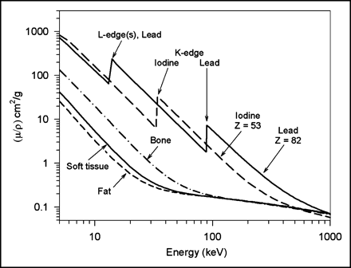
Figure 2 – Attenuation as a function of photon energy².
The attenuation coefficient of the material is closely linked to the material’s radiodensity. For radiographic use, radiodensity is measured in Hounsfield Units (HU). Water is chosen to have 0 HU, and anything with a higher radiodensity is positive while anything lower is negative. Fig. 3 shows some examples of different materials and their radiodensities in HU, as well as how they appear on an x-ray film. In an x-ray image, air (-200 to -1000 HU) appears black, water (0 HU) appears grey, and bone (300 to 500 HU) appears light grey, almost white.
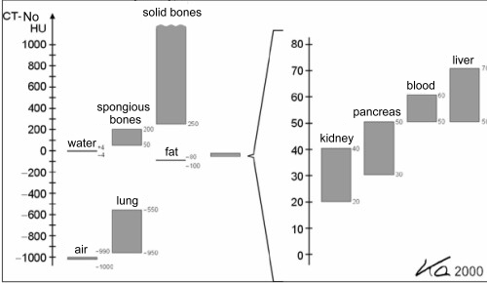
Figure 3 – Top: Different densities (in HU) of commonly x-rayed materials. Bottom: Grey scale for different materials³.
Experiment and Procedure
The easily constructed apparatus for this exercise safely models an x-ray machine. It uses an infrared LED array (infrared wavelength range: 0.74 µm to 0.3 mm), Congo blue filter around a box with unknown objects inside, and phosphor powder to create an image of the unknown object inside the filter. The infrared light passes through the filter with a very low loss of intensity to the phosphor screen. The objects, however, block the infrared light before it gets to the phosphor screen. Phosphor powder illuminates when exposed to infrared light, so a shadow of the unknown object is apparent on the screen. All of this is covered with a box so outside light does not interfere with the setup and make it difficult to get an image. A camera could be set up to take a picture of the image on the phosphor screen and send it to a computer for viewing.
- What is each part of this apparatus analogous to in terms of an x-ray machine?

- What are the main differences between this apparatus and a medical x-ray device?

- Calculate the frequency and energy range for infrared light.

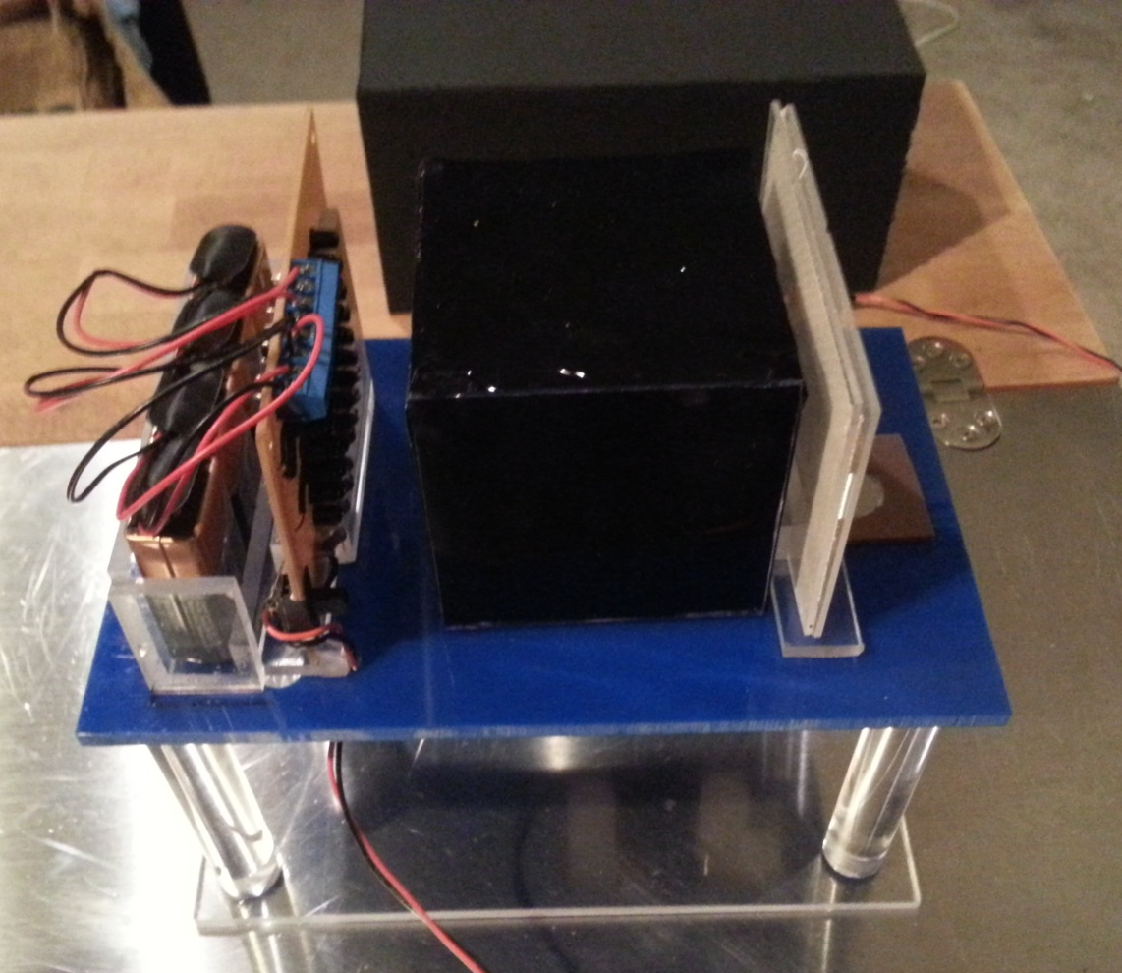
Figure 4 – Apparatus setup

Make sure each component is set up on the base as in Fig. 4. Attach the four 9V batteries to the circuit. Begin with nothing in between the LED array and the detector. Place the “Different materials sheet” between the infrared light and the phosphor screen and flip the switch on the circuit to turn on the LED’s. Place the box over the apparatus. Take a picture and observe the image. Approximate the percentage of the initial infrared light that passes through each type of material on the sheet. Mathematically, this would be expressed as: $Percentage=\frac{I}{I_{0}}*100\%$ where I₀ is the initial intensity of the light before it passes through any material, and I is the intensity after it passes through the material. This percentage serves as a rough estimate rather than a precise measurement.

Material 1 | Material 2 | Material 3

- How would the attenuation coefficients of these three materials compare?

- What is each material analogous to in terms of the human body?

There are different methods to retrieve an image in radiography: analog, digital, and analog to digital. For an analog image, photographic x-ray film is used. The image is created through direct x-ray exposure to the film, or the x-rays are often converted to visible light before the exposure of the film. Digital radiography is used in dentistry and is increasing in popularity due to advantages like higher sensitivity and the ease of storing and sharing data. The image is created using digital x-ray sensors rather than photographic film. Digital radiography eliminates the need for continual purchase of film, developing chemicals, and the disposal of both. There are two main types of digital detectors: charged coupled devices and flat panel detectors. A charged coupled device (CCD) utilizes a camera to take a picture of the image illuminating a plate. The second method, flat panel detectors, works by converting the x-rays to light or charge which is then converted to a digital image. The final method to retrieve an image, analog to digital, utilizes both processes. It allows traditional film x-rays to be converted to digital and viewed using a computer. This is achieved using a digital converter: using a viewing box, a digital camera is used to image the radiograph.
Analog: Remove the “Different Materials Sheet” and place the Congo blue box with the unknown objects on the platform. Replace the box over everything. Hold the button to turn on the LED array and observe the image on the phosphor screen.
- Draw the image.

- Rotate the platform 90 degrees and draw the image.

- Using the two images, sketch a 3 dimensional picture of the objects and their orientations inside the filter and briefly describe what the objects are.

Digital: Now, remove the shielding box and the phosphor screen. Using a cell phone (one without a strong infrared filter) take a picture of the box with the LED’s on. Rotate the box 90 degrees and take another picture. Many phones are able to photograph infrared light, so some phones should get an image, while others may not.
- How do these two images compare to the “analog” image on the phosphor screen?

Analog to Digital: Replace the phosphor screen and the shielding box. Turn on the LED array to create an image on the phosphor screen and take a picture of the phosphor screen. Rotate the box 90 degrees and do the same.
- How do all of the methods for detecting the image compare? What might be some pros and cons for each method?

- What are some possibilities to focus the infrared light to reduce shadowing effects of the image?

- How do x-ray machines reduce blurry images?

- Finally, fill in the table with how this apparatus is similar and dissimilar to an x-ray scanner.

 | Similarities | Differences
Light source
Detection
Image
(What shows up black in an x-ray and what shows up black in one of these images?)
Other

References
[1] "Journal of Nuclear Medicine Technology." X-Ray Imaging Physics for Nuclear Medicine Technologists. Part 2: X-Ray Interactions and Image Formation. N.p., n.d. Web. 30 Apr. 2014. <http://tech.snmjournals.org/content/33/1/3.figures-only>.

[2] J. H. Hubbell and S.M. Seltzer. Tables of X-Ray Mass Attenuation Coefficients and Mass Energy-Absorption Coefficients from 1 keV to 20 MeV for Elements Z = 1 to 92 and 48 Additional Substances of Dosimetric Interest. (1996). Accessed June 7, 2013 at http://www.nist.gov/pml/data/xraycoef/index.cfm
[3] Bentz, Matthew. (2008). A Brief Introduction to Radiology [PowerPoint slides].

